ΑΓΓΛΙΚΑ ΣΤ ΤΑΞΗ - 15/5/2020
ΕΠΑΝΑΛΗΨΗ:-UNIT 3 - LESSONS 2 AND 3
-Describing people
-Antonyms/Synonyms
-Adverbs
http://photodentro.edu.gr/v/item/ds/8521/3402 antonyms-word match
http://photodentro.edu.gr/v/item/ds/8521/3353 cloze test-Scylla and Charybdis
http://photodentro.edu.gr/v/item/ds/8521/6361 Describing people-picture dictionary
Remember some things about adverbs:
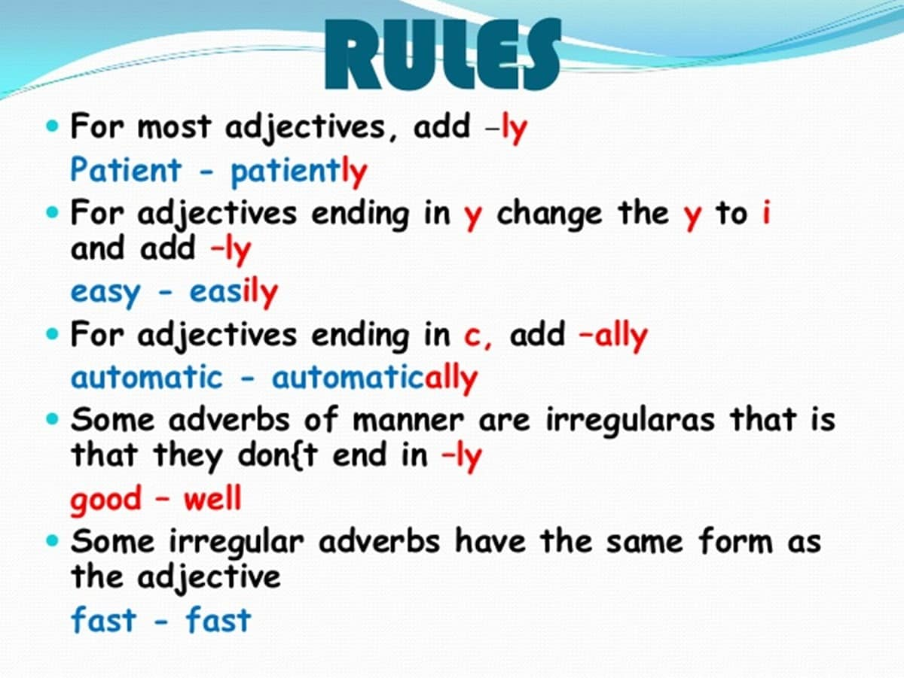
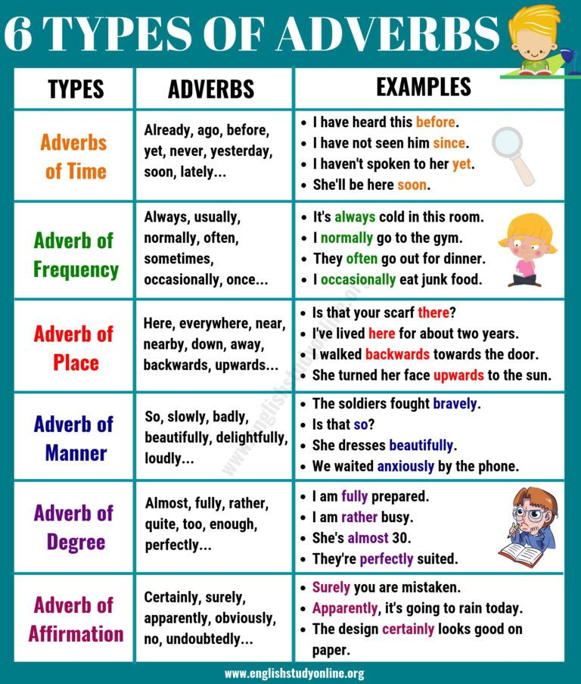

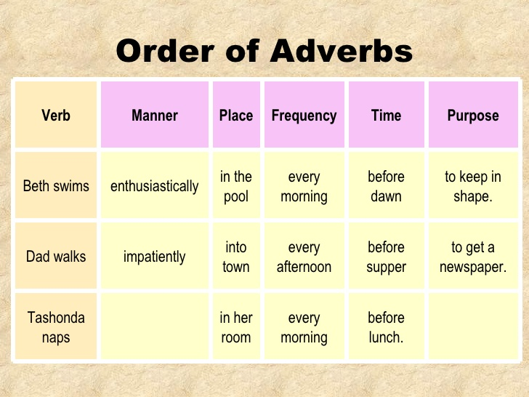
Now you can do the following activities:
https://www.ego4u.com/en/cram-up/grammar/adjectives-adverbs/exercises adjectives and adverbs
http://a4esl.org/q/f/z/zz60fck.htm quiz-adjective or adverb?
http://esl.fis.edu/grammar/multi/adadv.htm exercise
https://www.english-4u.de/en/grammar-exercises/adjective-adverb10.htmexercise
https://learningapps.org/171463 game
https://www.english-4u.de/en/grammar-exercises/word-order.htm word order

