ΑΓΓΛΙΚΑ ΣΤ ΤΑΞΗ - 7/5/2020
ΕΠΑΝΑΛΗΨΗ: -UNIT 3 - LESSONS 2 AND 3
-Imaginary creatures
-Comparisons(Positive, Comparative, Superlative)
Enjoy yourselves by watching the following (Ctrl+κλικ):
http://ebooks.edu.gr/modules/ebook/show.php/DSDIM-F101/441/2924,11597/extras/BC_Content/u3l2_Dark_dark_wood/activity.htmlDark Dark Wood-game
http://ebooks.edu.gr/modules/ebook/show.php/DSDIM-F101/441/2924,11597/extras/BC_Content/u3l2_The_haunted_house/activity.html A story about a haunted house
http://ebooks.edu.gr/modules/ebook/show.php/DSDIM-F101/441/2924,11597/extras/BC_Content/u3l2_Amazing_superheroes/activity.html Amazing Super Heroes
http://ebooks.edu.gr/modules/ebook/show.php/DSDIM-F101/441/2924,11597/extras/BC_Content/u3l2_Quiz_Superheroes/activity.html A Super Hero Quiz
http://photodentro.edu.gr/v/item/video/8522/787 A story: The fifty cent piece
http://photodentro.edu.gr/v/item/ds/8521/6714 The fifty cent piece-reading activity
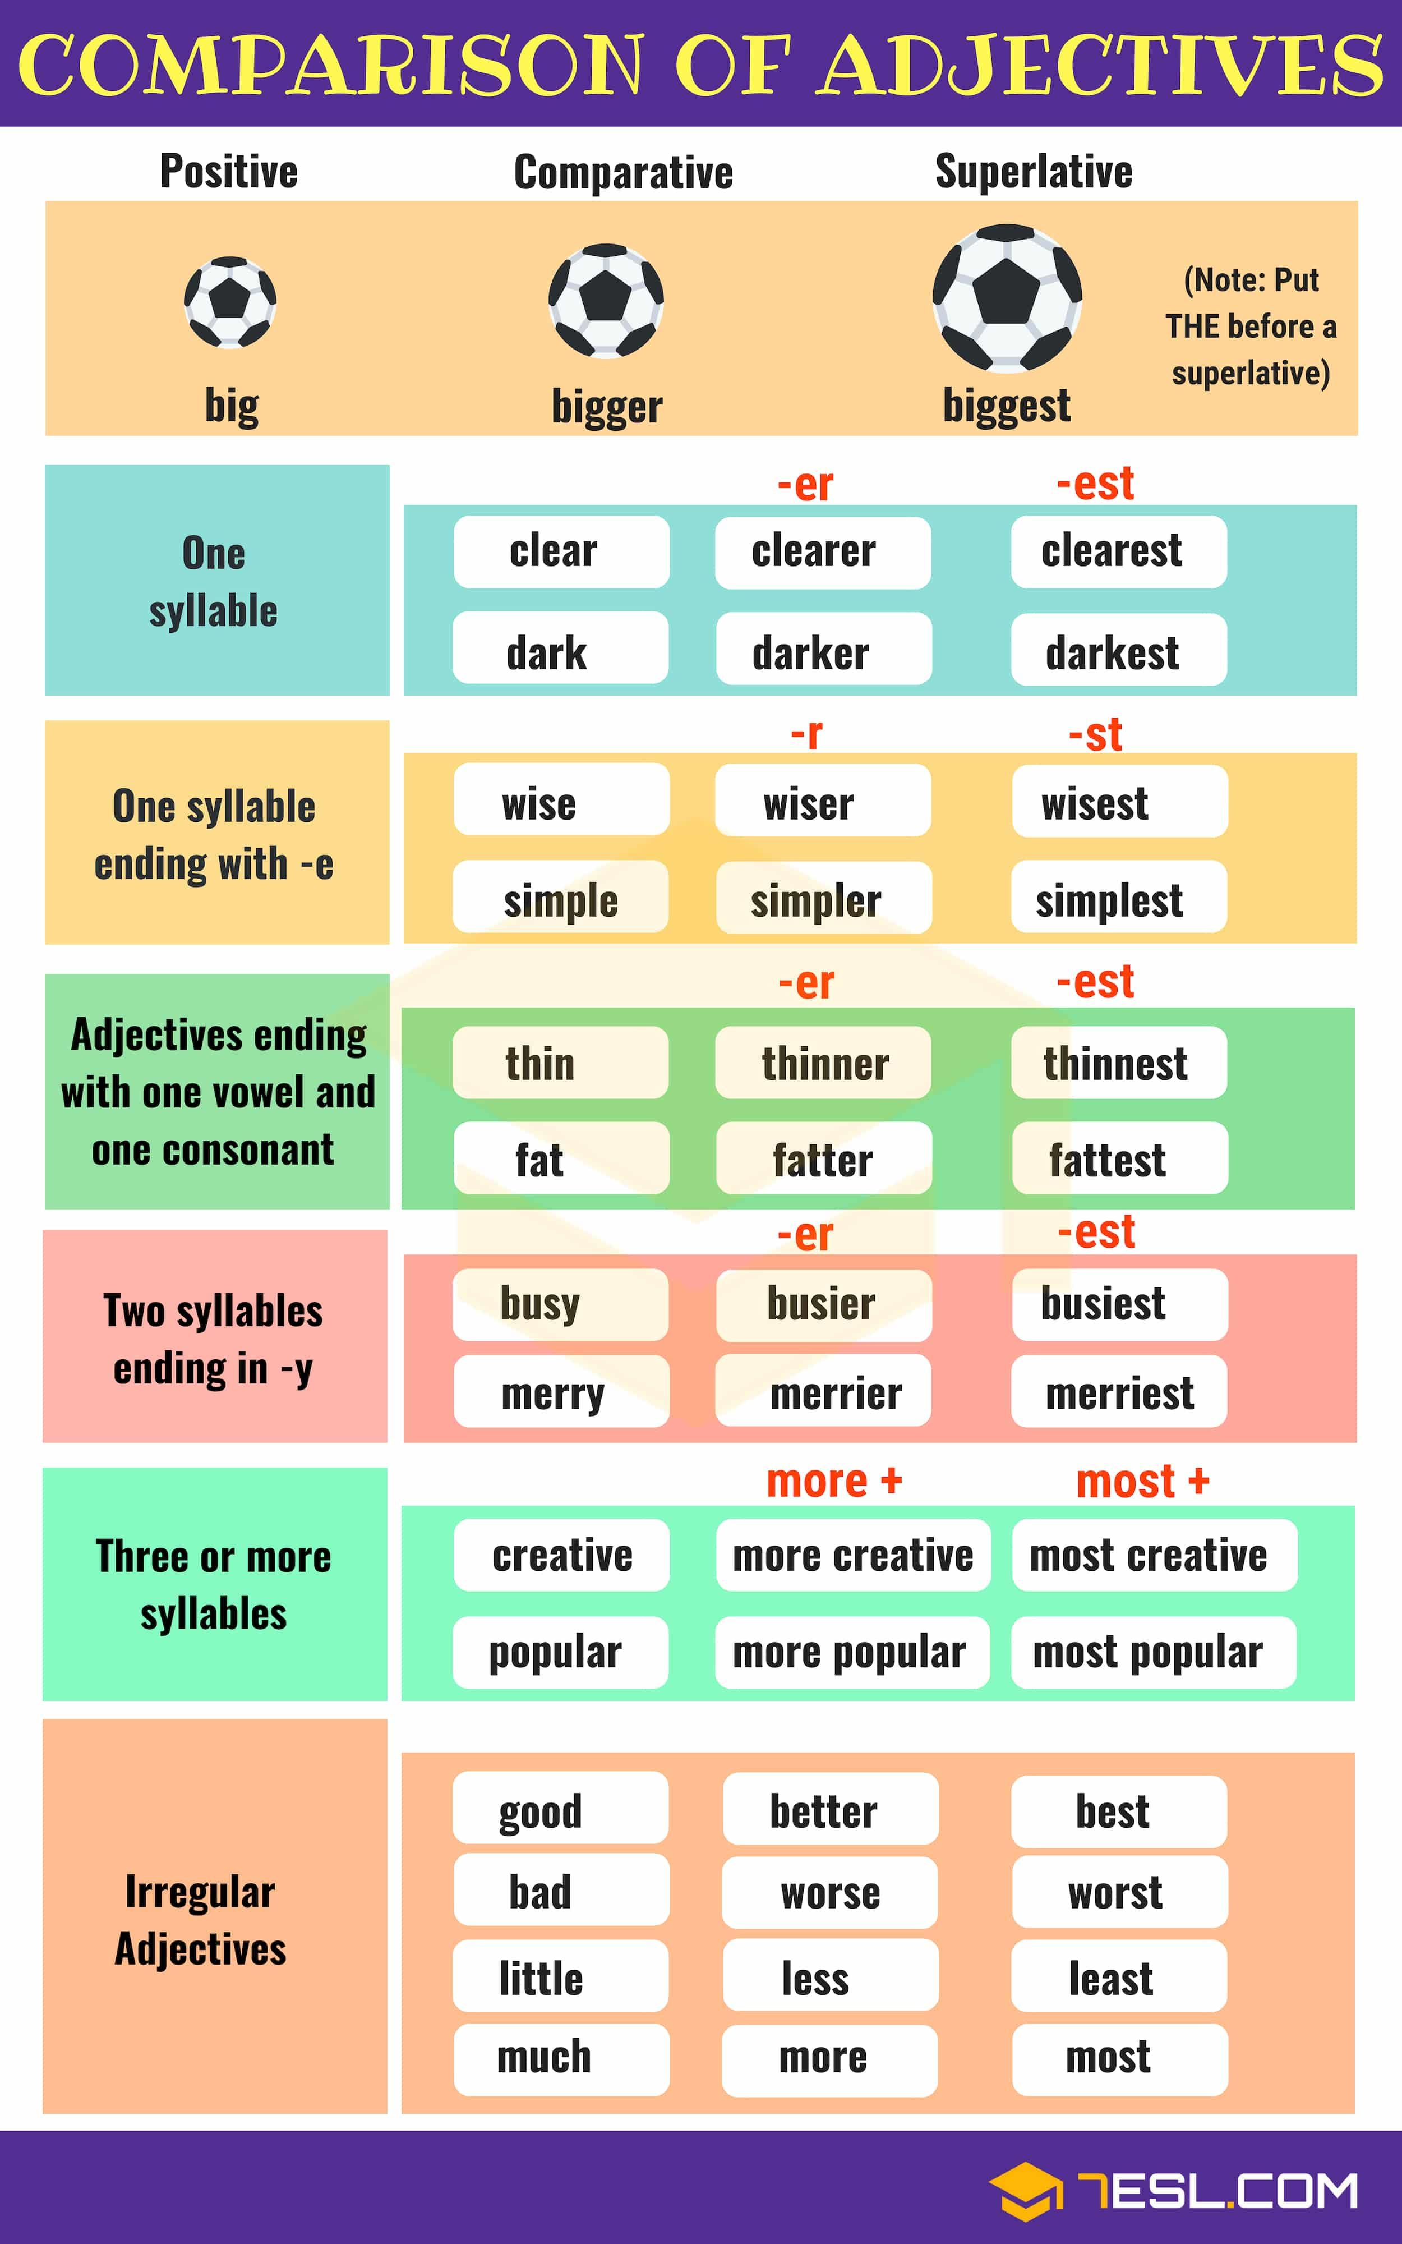
Now, try to do the following activities:
http://photodentro.edu.gr/v/item/ds/8521/3385 multiple choice/comparisons
(calm=ήρεμος, dull=ανιαρός,μουντός, broad=φαρδύς,πλατύς, monument=μνημείο)
http://photodentro.edu.gr/v/item/ds/8521/3384 multiple choice/comparisons
(trendy=μοντέρνος)
http://photodentro.edu.gr/v/item/ds/8521/3386 multiple choice/comparisons
gracefully=ευγενικά,χαριτωμένα, cheerfully=χαρούμενα, efficiently=ικανά,αποτελεσματικά, frequently=συχνά)
https://www.english-4u.de/en/grammar-exercises/comparison-adjectives.htm

