Falcon Marschall (1818-1878)

_______________________________________________________________________

Myles Birket Foster (1825-1899)

___________________________________________________________________________

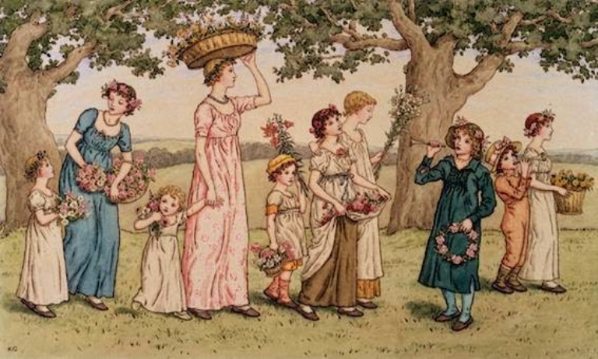

Kate Greenaway

___________________________________________________________________________

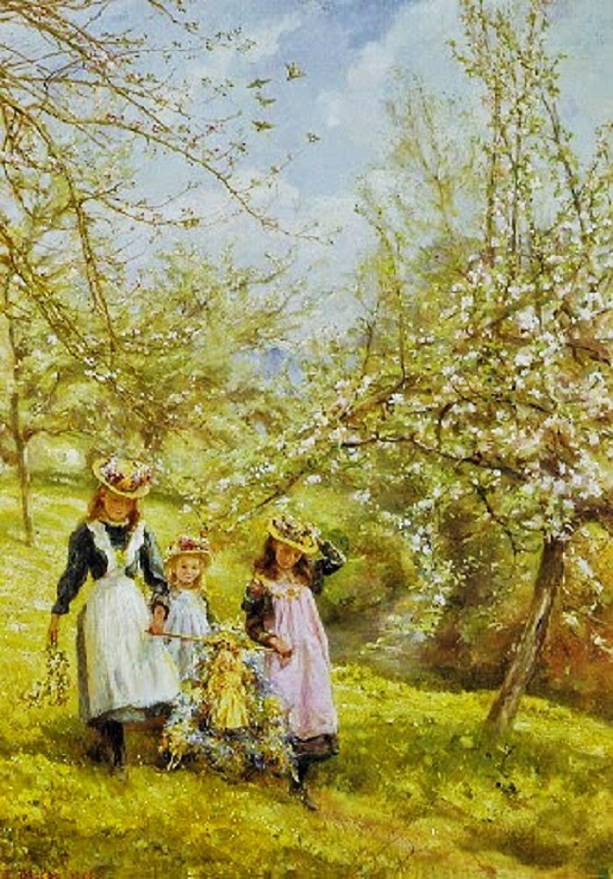
Edgar Barclay (1842-1913)

Λουκάς Γεραλής

__________________________________________________________________________

